[IoT based air pollution monitoring system](https://classroom.google.com/c/MzYwOTI0MzAxMTU5)

Name: Ayush Gaur

Contact: 9326730169

Email Id: [2018.ayush.gaur@ves.ac.in](mailto:2018.ayush.gaur@ves.ac.in)

# Index:

|  |  |  |
| --- | --- | --- |
| **sr.no** |  | **page.no** |
| **1.** | **Introduction** | 2 |
| **2.** | **Literature review** | 3 |
| **3.** | **Proposed solution** | 5 |
| **4.** | **Results** | 7 |
| **5.** | **Advantage and Disadvantage** | 9 |
| **6.** | **Applications** | 10 |
| **7.** | **Learning outcome** | 10 |
| **8.** | **conclusion** | 11 |
| **9.** | **References** | 11 |
| **10.** | **Appendix** | 12 |

**INTRODUCTION**

**A. Existing Problem:**

Air pollution a “silent public health emergency”. [Approximately 7 million premature deaths annually](https://www.who.int/airpollution/en/) are due to the effects of air pollution, about 4 million of which are due to ambient (outdoor) air pollution. Beyond shortening lives, air pollution can negatively impact our day-to-day lives, causing respiratory illness and leading to [days of missed work and school](https://www.oecd.org/env/tools-evaluation/thecostofairpollution.htm). [Children are especially vulnerable to the impacts of air pollution](http://www.euro.who.int/en/data-and-evidence/evidence-informed-policy-making/publications/hen-summaries-of-network-members-reports/what-are-the-effects-of-air-pollution-on-childrens-health-and-development): exposure to air pollution in early childhood, when the lungs are still developing, can lead to reduced lung capacity that persists through adulthood.

**Effects**:

Long-term health **effects** from **air pollution** include heart disease, lung cancer, and respiratory diseases such as emphysema. **Air pollution** can also cause long-term damage to people's nerves, brain, kidneys, liver, and other organs. Serious effects of air pollution also include

* + Global Warming.
  + Climate Change.
  + Acid Rain.
  + Smog **effect**.
  + Deterioration of fields.
  + Extinction of animal species.

**Overview:**

In this project we made an **IoT Based Air Pollution Monitoring System** which **monitors the Air Quality over a webserver using internet** and triggers an alarm when the air quality goes down beyond a certain level, means when there are sufficient amounts of harmful gases are present in the air like CO2, smoke, alcohol, benzene and NH3. It shows the air quality in PPM on the LCD and as well as on webpage so that it can be monitored very easily.

**Purpose:**

Main Purpose: To find out air quality index in ppm and representing it for ease of monitoring. Also uploading data onto firebase so as to get real time updates on web app and use the same for prediction of further AQI using machine learning model.

**LITERATURE REVIEW:**

Ambient air pollution is the leading environmental risk factor for disease globally. Air pollutants can increase the risk of some respiratory infections. . The studies were assessed for overall quality and risk of bias using standard criteria. The pollutant most frequently associated with statistically significant outcomes was fine particulate matter (< 2.5 µm; PM2.5); 6/11 studies assessed PM2.5, of which 4/6 demonstrated a significant association). There was some evidence of significant associations between PM10 (< 10 µm), nitrogen dioxide (NO2) and sulfur dioxide (SO2) , but these associations were inconsistent. The existing epidemiological evidence is limited and shows mixed results. However, it is plausible that exposure to air pollutants, particularly PM2.5, may suppress important immune defence mechanisms, increasing an individual's susceptibility, thus reducing mortality.

**Types of Air pollution:**

**Ambient air pollution:**

Ambient air pollution is a broader term used to describe air pollution in outdoor environments. Poor ambient air quality occurs when pollutants reach high enough concentrations to affect human health and/or the environment.

Worldwide 4.2 million premature deaths are attributable to ambient air pollution in 2016. About 88% of these deaths occurs in low and middle-income countries

**Outdoor Air pollution:**

The common sources of outdoor air pollution are emissions caused by combustion processes from motor vehicles, solid fuel burning and industry. Other pollution sources include smoke from bushfires, windblown dust,and biogenic emissions from vegetation (pollen and mould spores)

**Household Air pollution:**

Indoor air pollution is the degradation of indoor air quality by harmful chemicals and other materials; it can be up to 10 times worse than outdoor air pollution. This is because contained areas enable potential pollutants to build up more than open spaces. Statistics suggest that in developing countries, health impacts of indoor air pollution far outweigh those of outdoor air pollution. Indoor air pollution from solid fuels accounted for 3.5 million deaths and 4.5% global daily-adjusted life year (DALY) in 2010; it also accounted for 16% particulate matter pollution

**PROPOSED SOLUTION**

**BLOCK DIAGRAM**

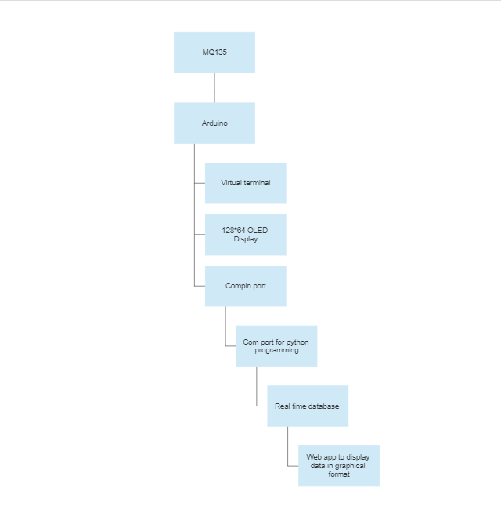

**FLOWCHART**

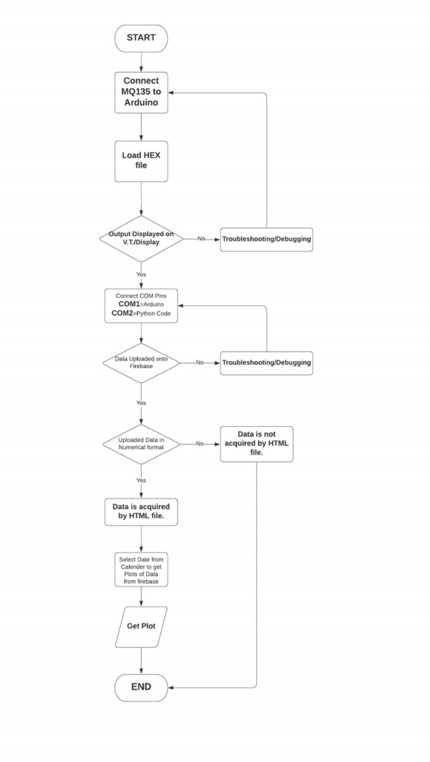

**RESULT:**

A. Fullscreen Screenshot of proteus.

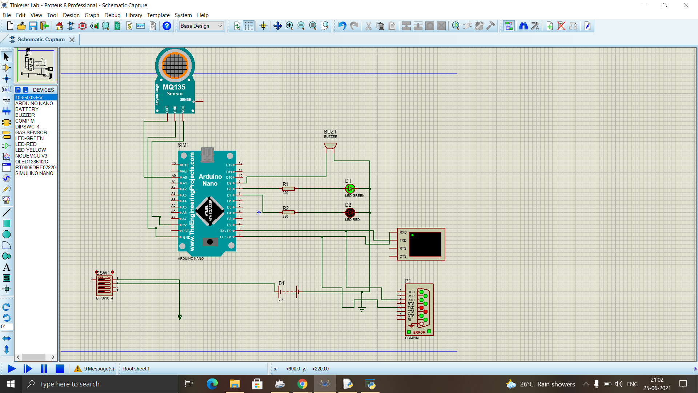

B. Data uploaded on firebase.(Firebase Window)

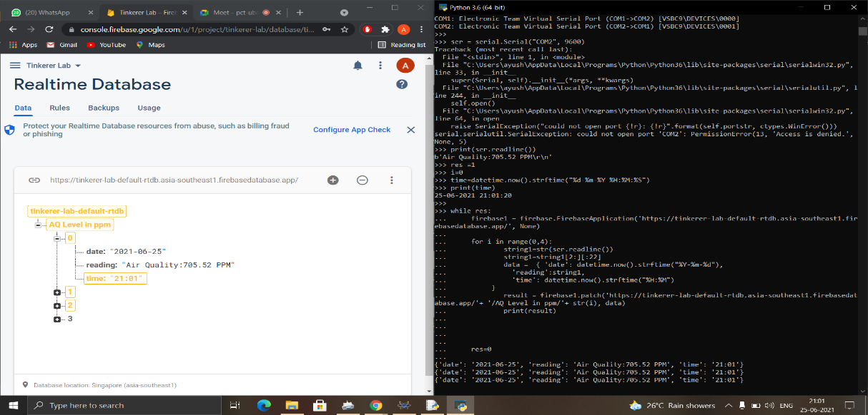

C. Screenshot of proteus while simulation.

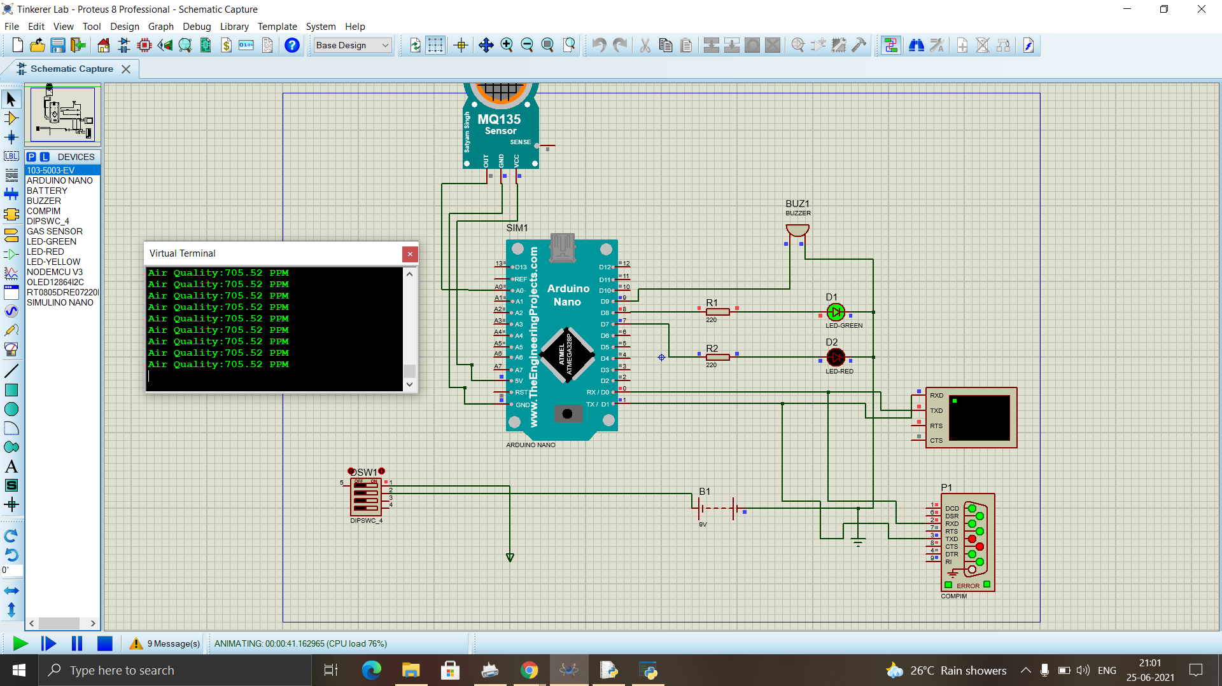

D)Submit the Screenshot of the Firebase real-time database( data can be of your choice). 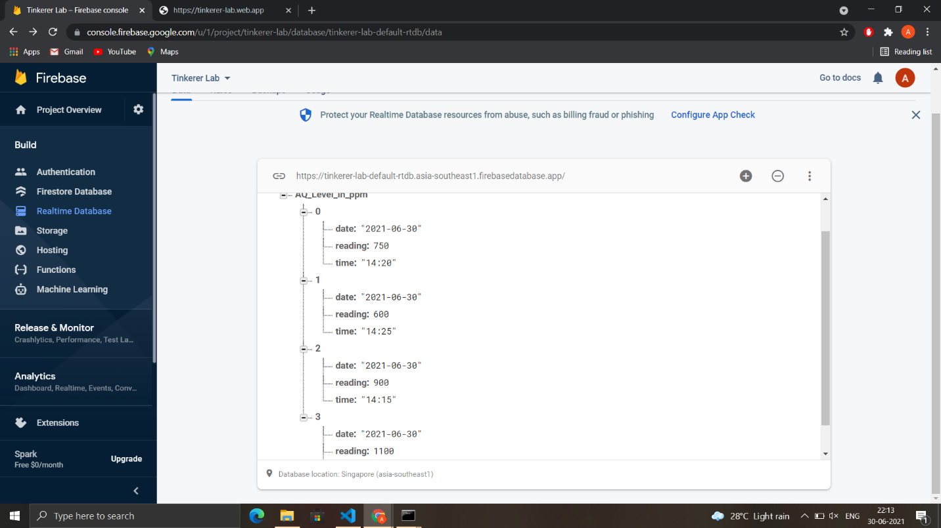

E)Submit the screenshot of the plotted graph in the HTML page.(The website url bar and chrome should be visible in the screenshot, to prove that you plotted it in HTML page)

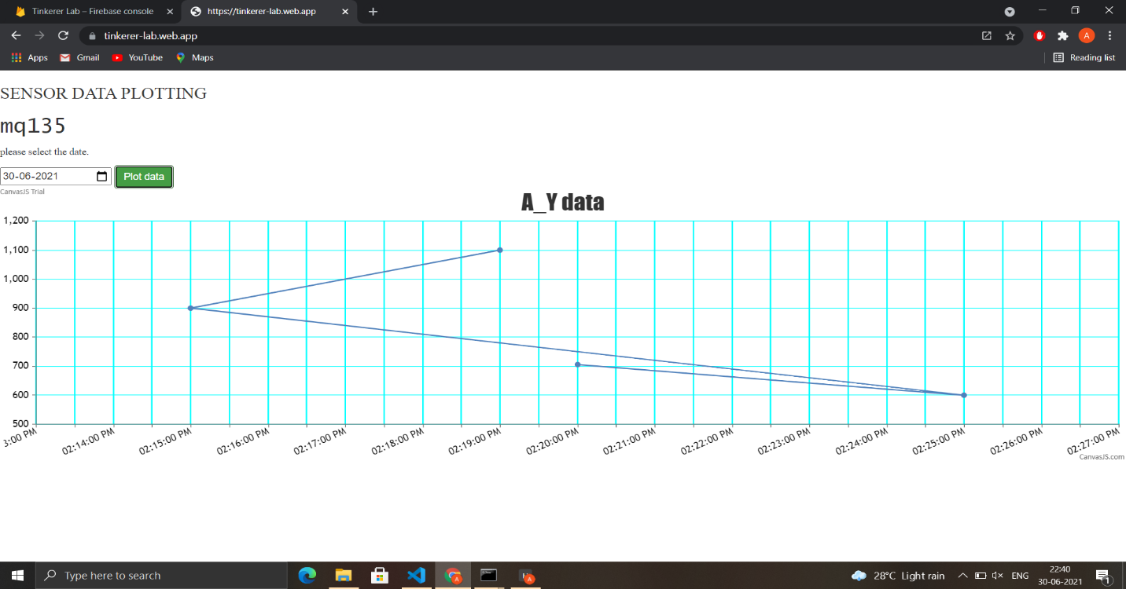

F) Link of deployed Webapp

<https://tinkerer-lab.web.app/>

**ADVANTAGES AND DISADVANTAGES**

**Advantages:**

1. Worldwide monitoring
2. Real-time alerts
3. Reduced wiring
4. Reduce cost
5. Easy installation
6. Easy maintenance and so on
7. Sensors are easily available.
8. Detecting a wide range of gases like CO2, CO etc.
9. Simple, compact and easily handle.
10. Continuous update of change in percentage of quality

**Disadvantages:**

1. Reliably detect and estimate small displacements
2. Determine column that moved
3. Estimate new locations of dislocated columns
4. Estimate location of slip surface
5. Faulty Readings

**Challenges:**

1. One of the major challenges here is large size and heavy weight of components.
2. Also, these are highly expensive.
3. In order to be effective, the locations of the monitoring stations need careful placement because the air pollution situation in urban areas is highly related to human activities.

**APPLICATION**

1. The system will show temperature and humidity. The system can be installed anywhere but mostly in industries and houses where gases are mostly to be found and gives an alert message when the system crosses threshold limit.
2. The system will show the air quality in PPM on the LCD and as well as on webpage so that it can be monitored very easily.

**LEARNING OUTCOMES**

1. Better Knowledge of proteus software, Arduino IDE and creation of Hex File.
2. Basic Understanding of Firebase – How data gets uploaded in real-time on it.
3. Practical experience with C programming for Arduino and Python programming for data upload.
4. Designing of Web App using HTML, CSS, JAVASCRIPT.
5. Linking HTML code with firebase to retrieve data from it.
6. Hosting, creation and deployment of WebApp.

**CONCLUSION**

The air pollution monitoring system is successfully implemented as a prototype. All the sensors and other stuff works as per the expectations. The sensors effectively sense the surrounding conditions and give the readings. The AQI readings are successfully acquired using MQ135 sensor. The system senses data and transmits it continuously. The data is successfully uploaded over firebase from where it is pushed to a machine learning code which then successfully displays the graph.

**REFERENCES**

1. Harsh N. Shah , Zishan Khan 2, Abbas Ali merchant3 , Moin Moghal 4, Aamir Shaikh 5, Priti Rane 6, IOT Based Air Pollution Monitoring System” Volume 9, Issue 2, February-2018 ISSN 2229-5518. Available: <http://www.jcreview.com/fulltext/197-1596370529.pdf>
2. Gagan Parmar1, Sagar Lakhani2, Manju 3 K. Chattopadhyay 4 An IoT Based Low Cost Air Pollution Monitoring System Proceeding 27-29 October,2017. Available: <http://www.jcreview.com/fulltext/197-1596370529.pdf>
3. Krishna, V. Siva, and S. Arun. "Embedded System Based Air Pollution Detection in Vehicles." (2015).Available:<https://www.researchgate.net/publication/327451321_Arduino-Based_Real_Time_Air_Quality_and_Pollution_Monitoring_System>
4. Section, Government of Canada, Health Canada, Healthy Environments and Consumer Safety Branch, Safe Environments Directorate, Water, Air and Climate Change Bureau, Air Quality Programs Division, Policy, Planning and Coordination. ["Air Pollution and Health - Environmental & Workplace Health - Health Canada"](http://www.hc-sc.gc.ca/ewh-semt/air/out-ext/health-sante/index-eng.php). Available: <https://www.canada.ca/en/health-canada/services/air-quality.html>
5. USGCRP (2009). Global Climate Change Impacts in the United States. In: Karl TR, Melillo JM, Peterson TC, editors. *Climate Change Impacts by Sectors: Ecosystems*. New York, NY: United States Global Change Research Program. Cambridge University Press. Available: https://www.frontiersin.org/articles/10.3389/fpubh.2020.00014/full.

**APPENDIX**

1. **Source code (Web App)**

<https://github.com/Tinkerers-Lab-VESIT-ETRX/IoT-based-air-pollution-monitoring-system-1/blob/e0a703713abebd202f2dcd2fe78f0796dc47215f/index.html>

<!DOCTYPE html>

<html lang="en">

<head>

<link rel="stylesheet" href="https://maxcdn.bootstrapcdn.com/bootstrap/3.3.7/css/bootstrap.min.css">

<script src="https://canvasjs.com/assets/script/canvasjs.min.js"></script>

</head>

<style>

h3{font-family: "Times New Roman", Times, serif;}

h2{font-family: "Lucida Console", "Courier New", monospace;}

p{font-family: "Papyrus";}

</style>

<body>

<h3>SENSOR DATA PLOTTING</h3>

<h2>mq135</h2>

<p>please select the date.</p>

<input type = "date" id="demo">

<button class="btn btn-success" type="button" onclick=myFunction()>Plot data</button>

<div id="chartContainer"></div>

<canvas id="chart" width="400" height="400"></canvas>

<script language = "javascript" type = "text/javascript">

function myFunction() {

var selectedDate=document.getElementById("demo").value;

console.log(selectedDate);

const Http = new XMLHttpRequest();

const url='https://tinkerer-lab-default-rtdb.asia-southeast1.firebasedatabase.app/AQ_Level_in_ppm.json';

Http.open("GET", url);

Http.send();

Http.onreadystatechange = () => {

if (Http.readyState == 4 && Http.status == 200) {

console.log(Http.responseText);

var resData=JSON.parse(Http.responseText);

console.log(resData);

var i;

var plotData=[];

for(i=0;i<resData.length;i++) {

var y=resData[i]['reading']

if(resData[i]['date']==selectedDate){

var temp1=resData[i]['date'].split('-');

var temp2=resData[i]['time'].split(':');

var x=new Date(temp1[0],temp1[1]-1,temp1[2],temp2[0],temp2[1]);

console.log(x,y);

plotData.push({x:x,y:y});

}

}

//console.log(plotData);

if(plotData.length!=0){

var chart = new CanvasJS.Chart("chartContainer",

{

title:{

text: "A_Y data"

},

axisX:{

gridColor: "cyan" ,

gridThickness: 2

},

axisY:{

gridColor: "cyan"

},

data: [

{

type: "line",

dataPoints: plotData

}

]

});

chart.render();

}

else{

document.getElementById("chartContainer").innerHTML="No data available for this date."

}

}

}

Http.open("GET", url);

Http.send();

}

</script>

</body>

</html>

1. **Source code(Arduino code)**

<https://github.com/Tinkerers-Lab-VESIT-ETRX/IoT-based-air-pollution-monitoring-system-1/blob/e0a703713abebd202f2dcd2fe78f0796dc47215f/Tinkerer_lab.ino>

#include "MQ135.h"

#include <SPI.h>

#include <Wire.h>

int RedLed = 9;

int GreenLed = 8;

int Buzzer = 7;

void setup()

{

pinMode(RedLed, OUTPUT);

pinMode(GreenLed, OUTPUT);

pinMode(Buzzer, OUTPUT);

Serial.begin(9600);

}

void loop()

{

MQ135 gasSensor = MQ135(A0);

float air_quality = gasSensor.getPPM();

Serial.print("Air Quality:");

Serial.print(air_quality);

Serial.println(" PPM");

if (air_quality<=1000)

{

digitalWrite(GreenLed, HIGH);

digitalWrite(RedLed,LOW);

noTone(Buzzer);

}

else if( air_quality>=1000 && air_quality<=2000 )

{

digitalWrite(GreenLed,LOW);

digitalWrite(RedLed, HIGH );

noTone(Buzzer);

}

else if (air_quality>=2000 )

{

digitalWrite(GreenLed,LOW);

digitalWrite(RedLed,HIGH);

tone(Buzzer, 1000, 200);

}

1. **Source code (Python data upload)**

<https://github.com/Tinkerers-Lab-VESIT-ETRX/IoT-based-air-pollution-monitoring-system-1/blob/e0a703713abebd202f2dcd2fe78f0796dc47215f/Tinkerer_lab.py>

import serial

from firebase import firebase

from time import sleep

from datetime import datetime

import serial.tools.list_ports

ports = serial.tools.list_ports.comports()

for port, desc, hwid in sorted(ports):

print("{}: {} [{}]".format(port, desc, hwid))

ser = serial.Serial("COM2", 9600)

print(ser.readline())

res =1

i=0

time=datetime.now().strftime("%d-%m-%Y %H:%M:%S")

print(time)

while res:

firebase1 = firebase.FirebaseApplication('https://tinkerer-lab-default-rtdb.asia-southeast1.firebasedatabase.app/', None)

for i in range(0,4):

string1=str(ser.readline())

string1=string1[2:][:22]

data = { 'date': datetime.now().strftime("%Y-%m-%d"),

'reading':string1,

'time': datetime.now().strftime("%H:%M")

}

result = firebase1.patch('https://tinkerer-lab-default-rtdb.asia-southeast1.firebasedatabase.app/'+ '/AQ_Level_in_ppm/'+ str(i), data)

print(result)

res=0